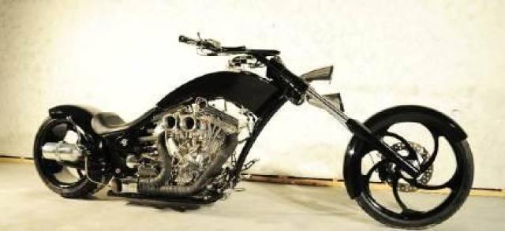
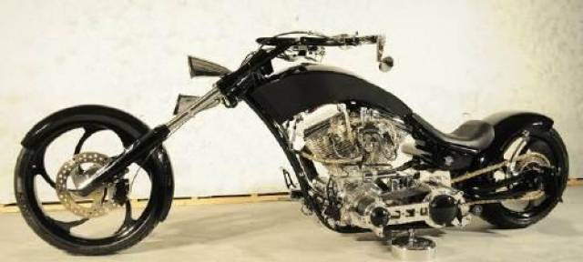
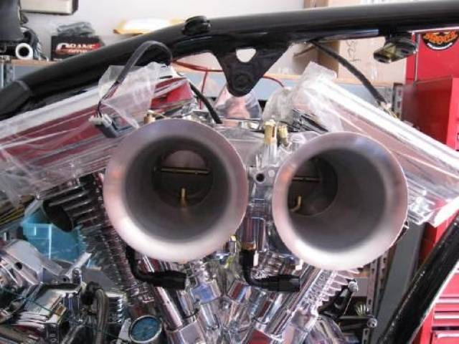
2010 Custom El Diablo Twister. Original Owner, Garage Kept, Engine: 145 CI, S&S Tribute Motor, 200 Rear Wheel HP W/ Out NOS, Wheels Are From Germany, Forward Controls Are From France, Nitrous Oxide Included, Everything Hand Built, Automatic Clutch, Auto Gear Shift, Well Maintained, Excellent Condition, Appraised at $87,000, this bike has won 1st place in every show I have put it in. including Rat's Hole in Daytona. is the definition of total custom and BAD ASS! It's a must see and must have!
